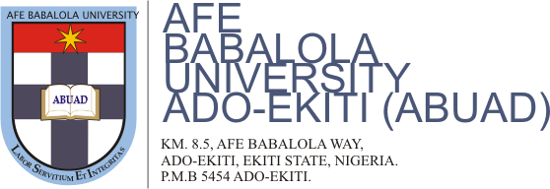

APPROVED ACADEMIC CALENDAR FOR 2017/2018 ACADEMIC SESSION

FIRST SEMESTER
1. Fresh Students’ for Registration and orientation
All students Monday 28th – Fri. 1st Sept. 2017
2. Returning Students Resumption and Registration Friday 1st September 2017
3. Lectures Begin - All Students Monday 4th September 2017
4. Late Registration with penalty Mon. 4th – Friday 15th Sept 2017
5. Convocation Saturday October 21st 2017
6. Matriculation Tuesday, 21st Nov. 2017
7. First Semester Examinations Mon. 27th Nov. – Fri. 15th Dec. 2017
8. End of First Semester Friday 15th Dec. 2017
9. First Semester Break Saturday 16th Dec. 2017
10. Marking and Processing of Results Sat 16th Dec. – Thur. 4th Jan., 2018
(a) Marking of Results Sat. 16th – 23rd December, 2017
(b) Departmental Examination Board Wed. 27th December, 2017
(c) College Examination Board Friday 29th December, 2017
(d) Provost Board Meeting – CPDD Wednesday 3rd January, 2018
(e) Senate Meeting Friday 5th January 2018
(f) Online Results Tuesday 9th January, 2018

SECOND SEMESTER
1. Students Resumption for Second Semester Begins Fri. 5th January, 2018
2. Lectures Begin Mon. 8th January, 2018
3. Second Semester Examinations – All students Mon. 16th April – 4th May, 2018
4. End of Session Friday 4th May, 2018
5. Students’ Vacation Sat. 6th May, 2018
6. Marking & Processing of Results Sat. 6th – 21st May, 2018
(a) Marking of Results Sun. 6th – 11th May, 2018
(b) Departmental Examination Board Tue. 15th May, 2018
(c) College Examination Board Thur. 17th May, 2018
(d) Provost Board Meeting – CPDD Monday 21st May, 2018
(e) Senate Meeting Wednesday 23rd May 2018
(f) Online Results Friday 25th May, 2018
7. Convocation Thursday, 21st June, 2018

